**FSD-CAPSTONE PROJECT: Health Care Application.**

**Angular Part:-**

**List users:**

**List User:**

**Register component:**

**Service component:**

**App Component:**

**App Component.spec.ts**

**Backend Part in Eclipse:**

**User Controller:**

**Entity: Category, Medicine , Order and User.**

**Service:**

**Application Properties:**

**Get All API Response:**

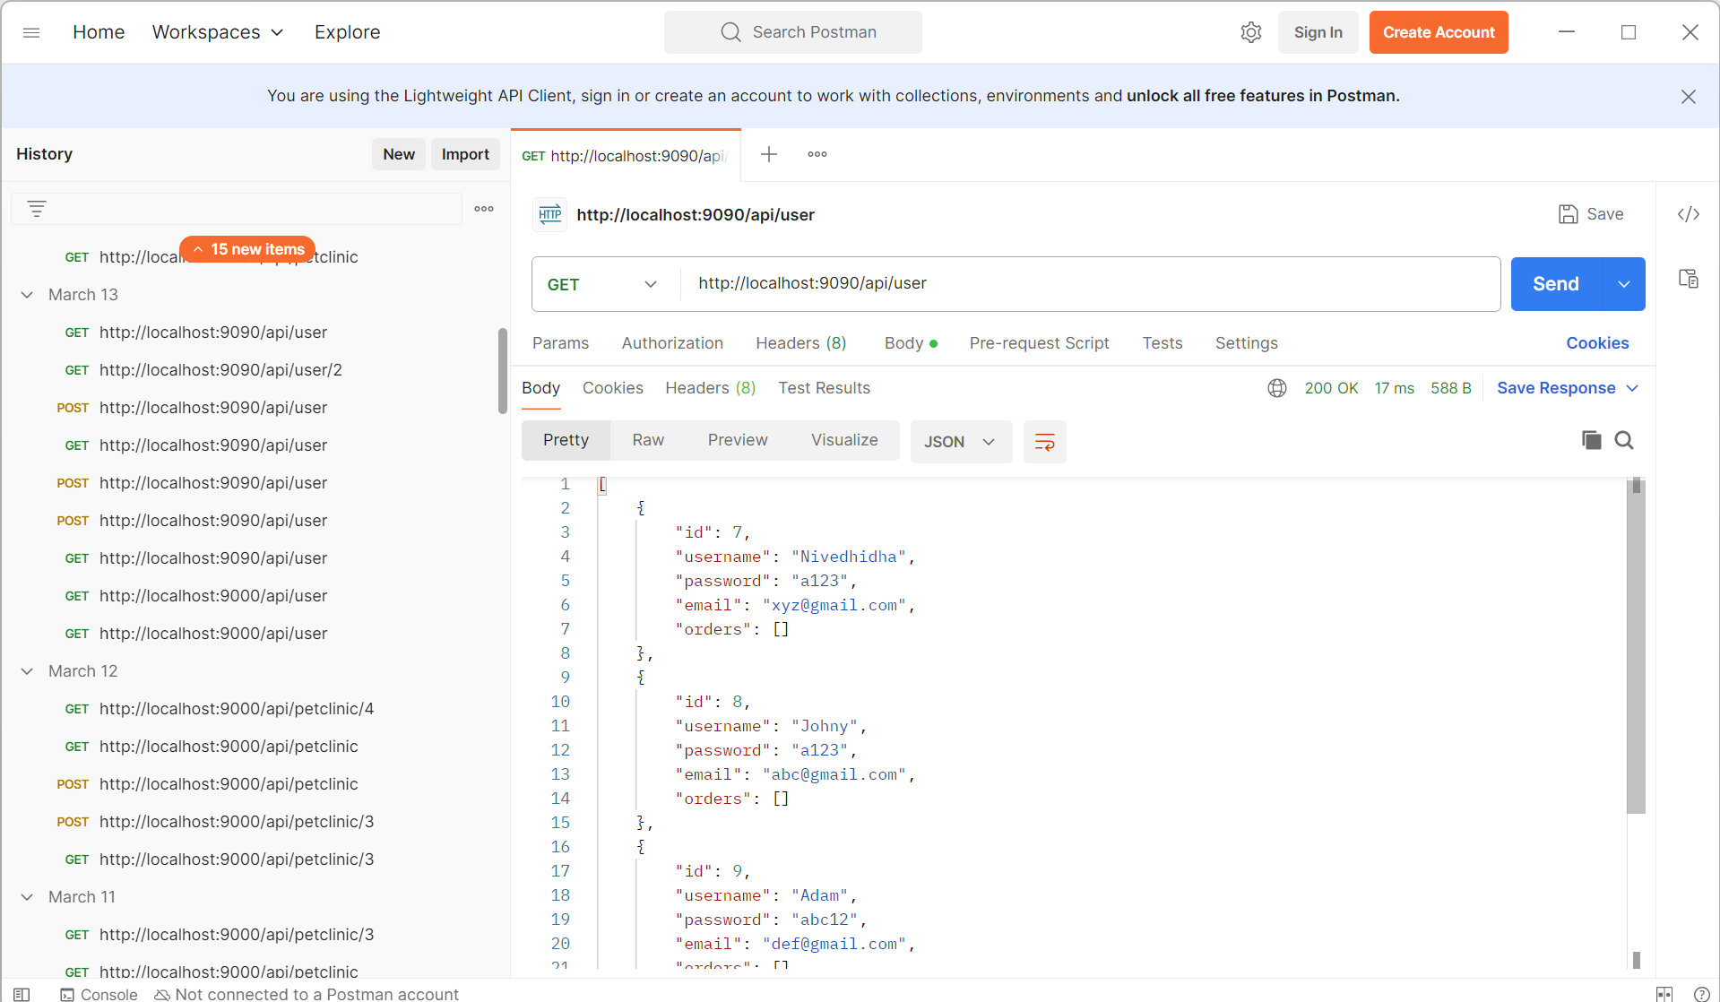

**Post Object:**

**Get Object by Id:**

**Database: Capstone.**

**Local Host Response:**

**Output Screen.**

**Registration Screen.**

**UserList.**

**Jenkins Capstone Project:**

